**Pod Logs**

Follow the steps given below to update your Deployment:

1. List the pods

kubectl get pods

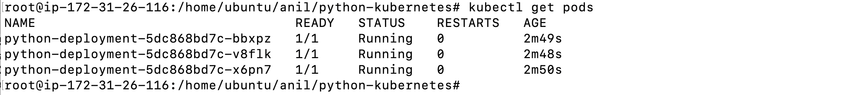

1. You can use any pod name to check the logs

kubectl logs python-deployment-5dc868bd7c-bbxpz

1. List logs for all 3 pods and notice that 200 request log of your visit to site is showing up

============================ completion of Lab =======================================